SQL Queries

Instagram

Visual 1
Sum of Engagement by Month :
-- sum of engagement by month (instagram)
SELECT
MONTH(PostDate) AS MonthNumber,
DATENAME(MONTH, PostDate) AS MonthName,
SUM(Engagement) AS Total_Engagement
FROM contentdata
WHERE PlatformID = 2
GROUP BY
MONTH(PostDate),
DATENAME(MONTH, PostDate)
ORDER BY MonthNumber;

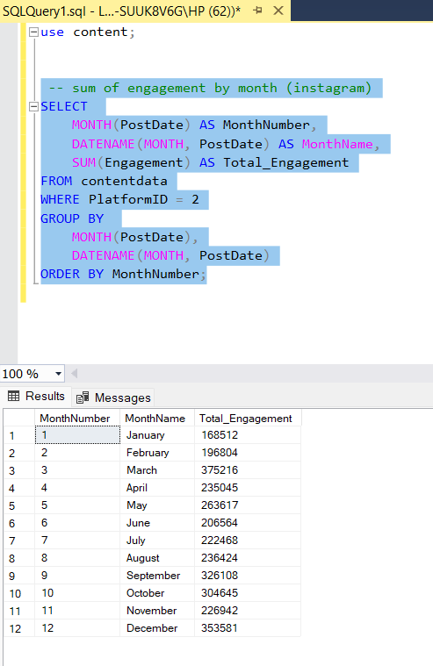

Visual 2
Sum of Engagement and Sum of Reach
-- sum of engagement and sum of reach
select
sum(Engagement) as Sum_of_Engegament ,
sum(Reach) as Sum_of_Reach
from contentdata
where Platform='Instagram';

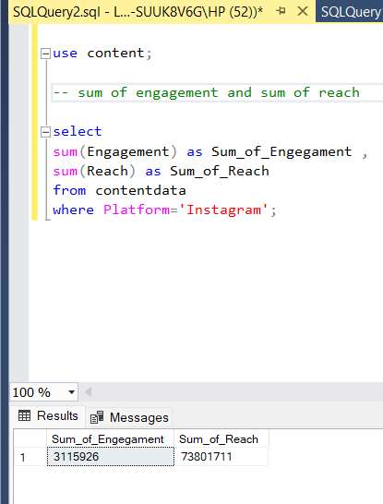

Visual 3 :
Total Engagement by PostType
-- Total Engagement by PostType
select PostType,SUM(Engagement) as Total_Engagement
from contentdata
where Platform = 'Instagram'
group by PostType;
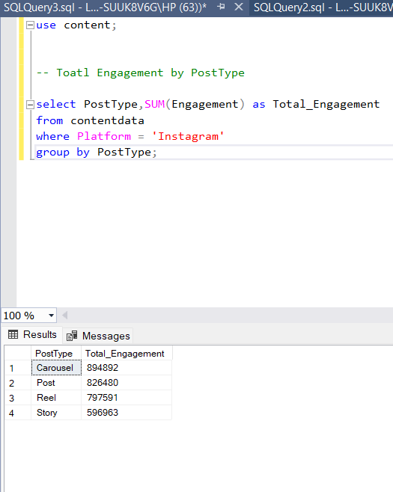

Visual 4:
Total Engagement by Category
-- Total Engagement by Category

select Category,SUM(Engagement) as Total_Engagement
from contentdata
where Platform = 'Instagram'
group by Category;

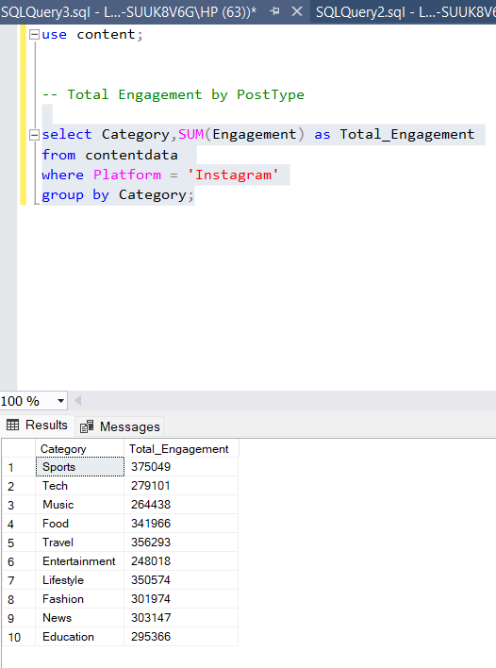

Snapchat
Visual 1: Total Reach VS Total Engagement in MonthName
-- Total Reach VS Total Engagement in MonthName
SELECT
MONTH(PostDate) AS MonthNumber,
DATENAME(MONTH, PostDate) AS MonthName,
SUM(Reach) AS Total_Reach,
SUM(Engagement) AS Total_Engagement
FROM contentdata
WHERE Platform = 'Snapchat'
GROUP BY
MONTH(PostDate),
DATENAME(MONTH, PostDate)
ORDER BY
MonthNumber;
- MONTH(PostDate) extracts the month number for correct chronological order.
- DATENAME(MONTH, PostDate) extracts the month name for readable labels.
- SUM(Reach) calculates the total audience reached each month.
- SUM(Engagement) calculates the total user interactions each month.WHERE Platform = 'Snapchat' filters data for Snapchat only.
- GROUP BY aggregates all posts month-wise.
- ORDER BY MonthNumber ensures January to December sorting.
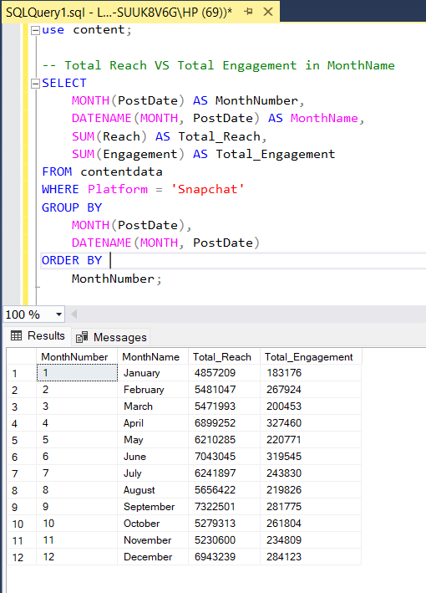
Visual 2: Total Engagement by PostType
--Total Engagement by PostType
SELECT
PostType,
SUM(Engagement) AS Total_Engagement
FROM contentdata
WHERE Platform = 'Snapchat'
GROUP BY PostType
ORDER BY Total_Engagement DESC;
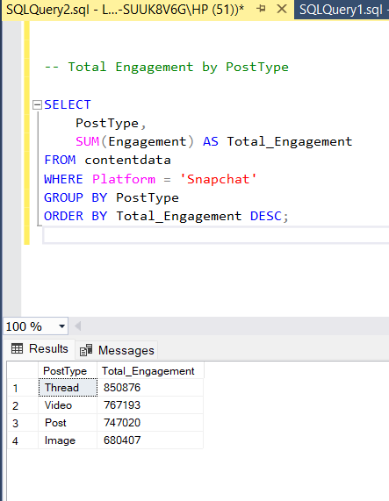

Visual 3: Engagement Rate by PostType(snapchat)
-- Engagement Rate by PostType(snapchat)
SELECT
PostType,
ROUND(
(SUM(Engagement) * 100.0) / NULLIF(SUM(Reach), 0),
2
) AS Engagement_Rate_Percent
FROM contentdata
WHERE Platform = 'Snapchat'
GROUP BY PostType
ORDER BY Engagement_Rate_Percent DESC;

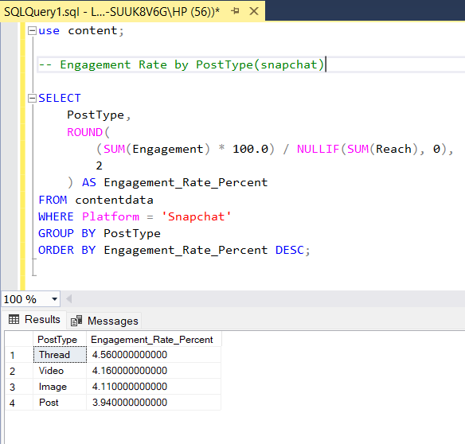

Groups content by PostType
Calculates Engagement Rate = (Engagement ÷ Reach) × 100
Prevents divide-by-zero errors

Visual 4 : Total Engagement by Category (Snapchat)

-- Total Engagement by Category

SELECT
Category,
SUM(Engagement) AS Total_Engagement
FROM contentdata
WHERE Platform = 'Snapchat'
GROUP BY Category
ORDER BY Total_Engagement DESC;
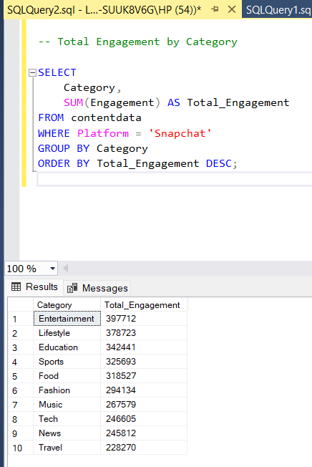

Twitter

Visual 1 : Total Reach by PostType
SELECT
PostType,
SUM(Reach) AS Total_Reach
FROM contentdata
WHERE Platform = 'Twitter'
GROUP BY PostType
ORDER BY Total_Reach DESC;
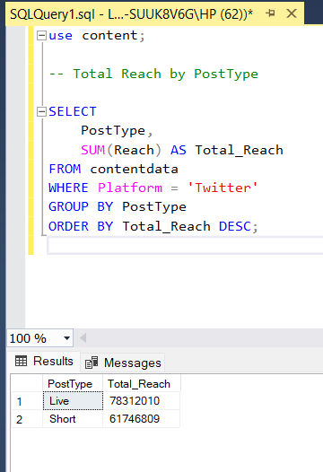

Visual 2 : Total Reach & Total Engagement by MonthName

SELECT
MONTH(PostDate) AS MonthNumber,
DATENAME(MONTH, PostDate) AS MonthName,
SUM(Reach) AS Total_Reach,
SUM(Engagement) AS Total_Engagement
FROM contentdata
WHERE Platform = 'Twitter'
GROUP BY
MONTH(PostDate),
DATENAME(MONTH, PostDate)
ORDER BY MonthNumber;
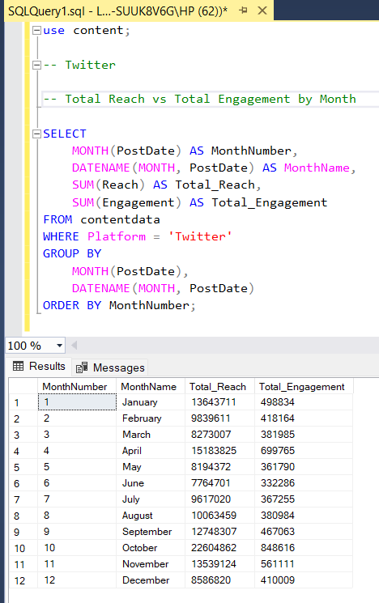

Visual 3 : Category vs PostType (TABLE / MATRIX VISUAL)

SELECT
Category,
SUM(CASE WHEN PostType = 'Live' THEN Reach ELSE 0 END) AS Live,
SUM(CASE WHEN PostType = 'Short' THEN Reach ELSE 0 END) AS Short,
SUM(Reach) AS Total
FROM contentdata
WHERE Platform = 'Twitter'
GROUP BY Category
UNION ALL
SELECT
'Total',
SUM(CASE WHEN PostType = 'Live' THEN Reach ELSE 0 END),
SUM(CASE WHEN PostType = 'Short' THEN Reach ELSE 0 END),
SUM(Reach)
FROM contentdata
WHERE Platform = 'Twitter';
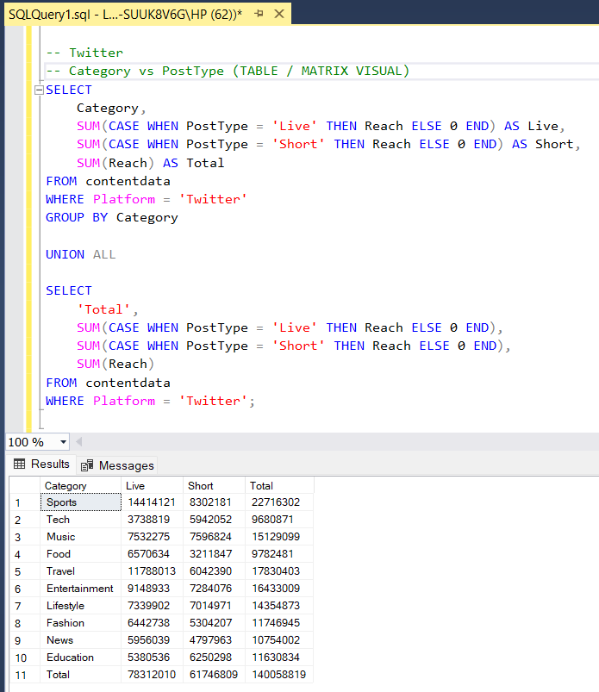
Explanation :
SELECT Category,
This line selects the Category column, which becomes the row label in the matrix (for example: Education, Promotion, Announcement, etc.).

SUM(CASE WHEN PostType = 'Live' THEN Reach ELSE 0 END) AS Live,
This calculates the total Reach only for Live posts within each Category.
The CASE condition checks each row:
– If PostType is Live, it includes the Reach value
– Otherwise, it adds 0
SUM then adds all those values to give total Live Reach per Category.
SUM(CASE WHEN PostType = 'Short' THEN Reach ELSE 0 END) AS Short,
This works the same way as the previous line but calculates total Reach for Short posts in each Category.
This creates a separate column for Short post Reach.
SUM(Reach) AS Total
This sums the Reach of all posts, regardless of PostType, giving the row-level total Reach per Category.
FROM contentdata
This specifies the source table that contains all social media post data.
WHERE Platform = 'Twitter'
This filters the data so only Twitter records are included in the calculation.
GROUP BY Category
This groups all rows by Category so that the SUM calculations are done category-wise, producing one row per Category.
UNION ALL
This combines the result of the first query with another query without removing duplicates, which is necessary here because we want to append a total row, not merge data.
SELECT 'Total',
This creates a custom row label called Total, which will appear as the last row in the matrix.
SUM(CASE WHEN PostType = 'Live' THEN Reach ELSE 0 END),
This calculates the overall Live Reach across all Categories for Twitter.
SUM(CASE WHEN PostType = 'Short' THEN Reach ELSE 0 END),
This calculates the overall Short Reach across all Categories for Twitter.
SUM(Reach)
This calculates the grand total Reach for all Twitter posts.
FROM contentdata
Again references the same dataset to calculate overall totals.
WHERE Platform = 'Twitter';
Ensures the total row includes only Twitter data, keeping it consistent with the matrix above.
Visual 4 : Total Reach by Category
SELECT
Category,
SUM(Reach) AS Total_Reach
FROM contentdata
WHERE Platform = 'Twitter'
GROUP BY Category
ORDER BY Total_Reach DESC;
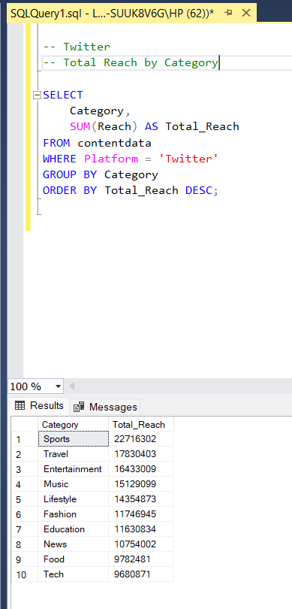

Youtube
Visual 1 : Total Views & Total Engagement by MonthName
SELECT
MONTH(PostDate) AS MonthNumber,
DATENAME(MONTH, PostDate) AS MonthName,
SUM(Views) AS Total_Views,
SUM(Engagement) AS Total_Engagement
FROM contentdata
WHERE Platform = 'YouTube'
GROUP BY
MONTH(PostDate),
DATENAME(MONTH, PostDate)
ORDER BY MonthNumber;
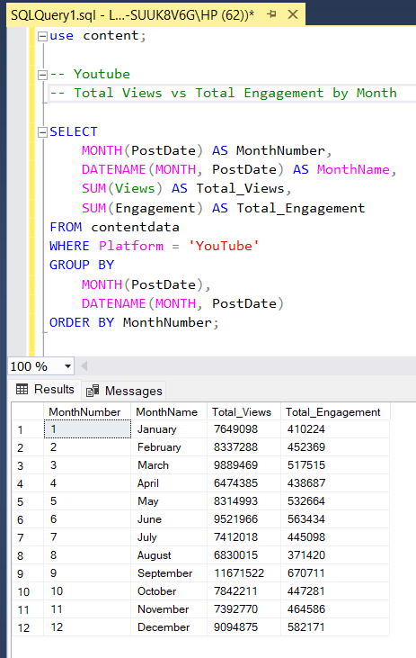

Visual 2 : Total Views by Category
SELECT
Category,
SUM(Views) AS Total_Views
FROM contentdata
WHERE Platform = 'YouTube'
GROUP BY Category
ORDER BY Total_Views DESC;
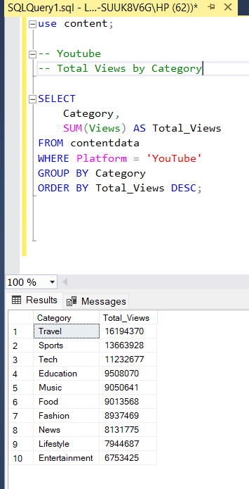

Visual 3 : Total Engagement by PostType
SELECT
PostType,
SUM(Engagement) AS Total_Engagement
FROM contentdata
WHERE Platform = 'YouTube'
GROUP BY PostType
ORDER BY Total_Engagement DESC;
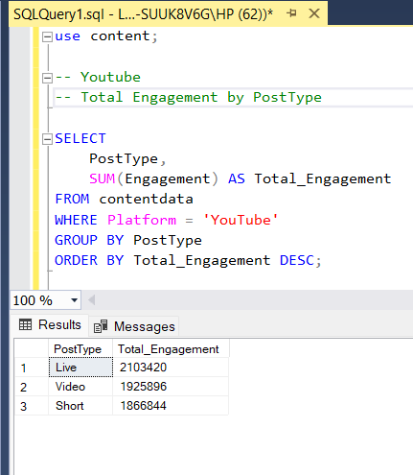
Visual 4 : Engagement Rate by PostType
SELECT
PostType,
ROUND(
(SUM(Engagement) * 100.0) / NULLIF(SUM(Views), 0),
2
) AS Engagement_Rate_Percent
FROM contentdata
WHERE Platform = 'YouTube'
GROUP BY PostType
ORDER BY Engagement_Rate_Percent DESC;
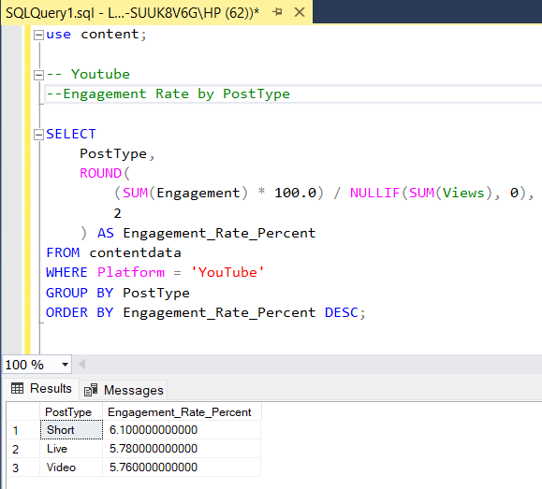
Facebook
Visual 1 : Total Reach & Total Engagement by MonthName
SELECT
MONTH(PostDate) AS MonthNumber,
DATENAME(MONTH, PostDate) AS MonthName,
SUM(Reach) AS Total_Reach,
SUM(Engagement) AS Total_Engagement
FROM contentdata
WHERE Platform = 'Facebook'
GROUP BY
MONTH(PostDate),
DATENAME(MONTH, PostDate)
ORDER BY MonthNumber;
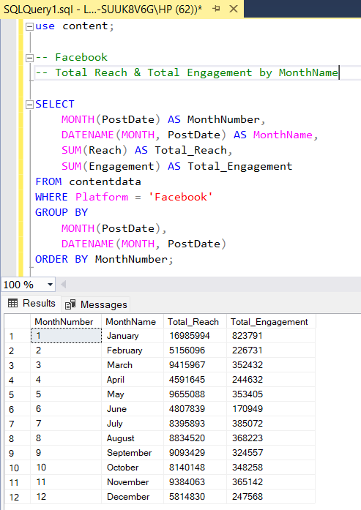

Visual 2 : Total Engagement by PostType
SELECT
PostType,
SUM(Engagement) AS Total_Engagement
FROM contentdata
WHERE Platform = 'Facebook'
GROUP BY PostType
ORDER BY Total_Engagement DESC;
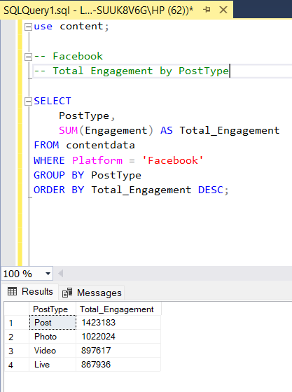

Visual 3 : Engagement Rate % by PostType
SELECT
PostType,
ROUND(
(SUM(Engagement) * 100.0) / NULLIF(SUM(Reach), 0),
2
) AS Engagement_Rate_Percent
FROM contentdata
WHERE Platform = 'Facebook'
GROUP BY PostType
ORDER BY Engagement_Rate_Percent DESC;
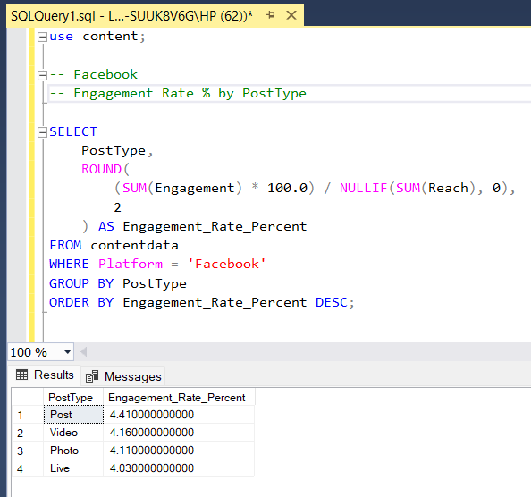

Visual 4 : Total Reach by Category
SELECT
Category,
SUM(Reach) AS Total_Reach
FROM contentdata
WHERE Platform = 'Facebook'
GROUP BY Category
ORDER BY Total_Reach DESC;
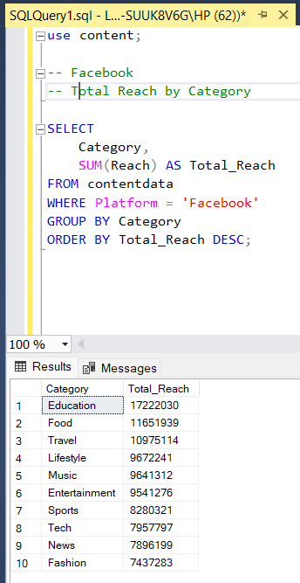

Linkedln

Visual 1 : Total Reach & Total Engagement by MonthName
SELECT
MONTH(PostDate) AS MonthNumber,
DATENAME(MONTH, PostDate) AS MonthName,
SUM(Reach) AS Total_Reach,
SUM(Engagement) AS Total_Engagement
FROM contentdata
WHERE Platform = 'LinkedIn'
GROUP BY
MONTH(PostDate),
DATENAME(MONTH, PostDate)
ORDER BY MonthNumber;
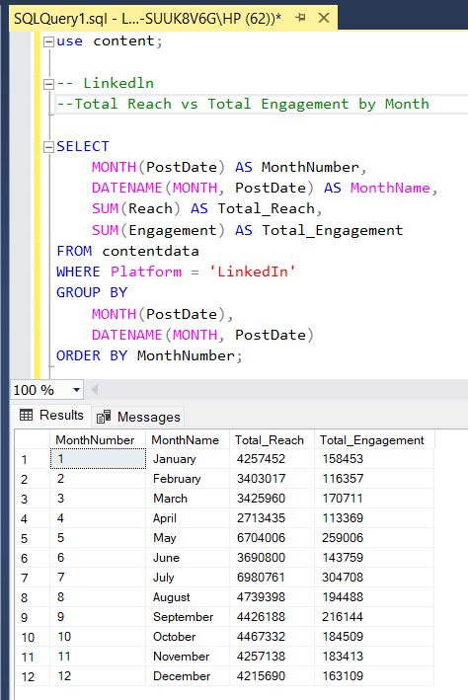

Visual 2 : Total Engagement by PostType
SELECT
PostType,
SUM(Engagement) AS Total_Engagement
FROM contentdata
WHERE Platform = 'LinkedIn'
GROUP BY PostType
ORDER BY Total_Engagement DESC;
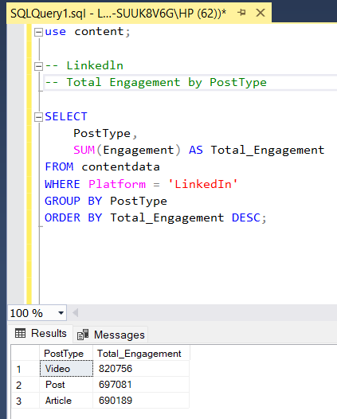
Visual 3 : Total Reach by Category
SELECT
Category,
SUM(Reach) AS Total_Reach
FROM contentdata
WHERE Platform = 'LinkedIn'
GROUP BY Category
ORDER BY Total_Reach DESC;
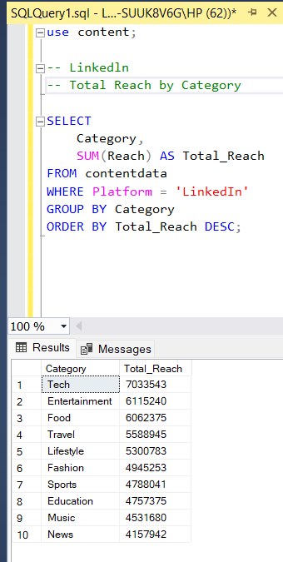
Visual 4 : Engagement Rate % by PostType
SELECT
PostType,
ROUND(
(SUM(Engagement) * 100.0) / NULLIF(SUM(Reach), 0),
2
) AS Engagement_Rate_Percent
FROM contentdata
WHERE Platform = 'LinkedIn'
GROUP BY PostType
ORDER BY Engagement_Rate_Percent DESC;
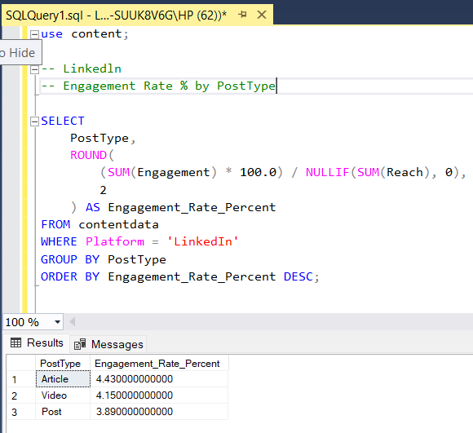

Comparision Dashboard
Visual 1 : Total Engagement by Category and Platform
SELECT
Platform,
Category,
SUM(Engagement) AS Total_Engagement
FROM contentdata
GROUP BY Platform, Category
ORDER BY Platform, Total_Engagement DESC;
Use in Power BI
- Axis / Rows → Category
- Legend / Columns → Platform
- Values → Total_Engagement

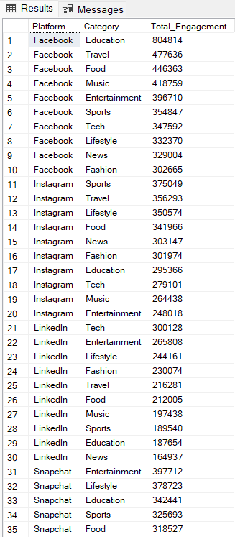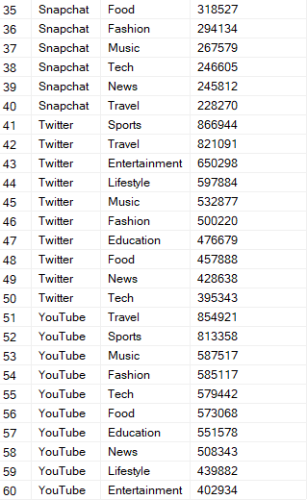

Visual 2 : Total Reach by Platform
SELECT
Platform,
SUM(Reach) AS Total_Reach
FROM contentdata
GROUP BY Platform
ORDER BY Total_Reach DESC;
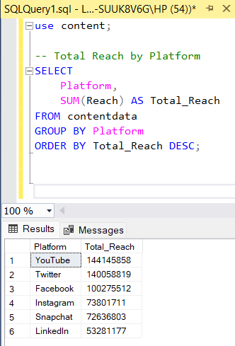

Visual 3: Engagement Rate % by Platform
SELECT
Platform,
ROUND(
(SUM(Engagement) * 100.0) / NULLIF(SUM(Reach), 0),
2
) AS Engagement_Rate_Percent
FROM contentdata
GROUP BY Platform
ORDER BY Engagement_Rate_Percent DESC;
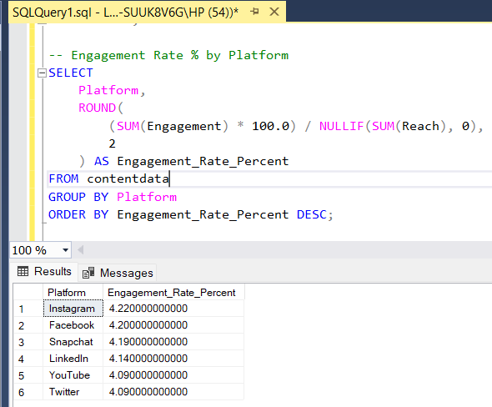
Visual 4 : Total Engagement by Platform
SELECT
Platform,
SUM(Engagement) AS Total_Engagement
FROM contentdata
GROUP BY Platform
ORDER BY Total_Engagement DESC;
